

**American International University- Bangladesh**

**CSC 3215: Web Technologies**

**CO1 and CO3 Evaluation**

**Project Report**

**Spring 2019-2020**

**Project Title: Human Resource Management System**

**Section: G**

|  |  |
| --- | --- |
| Student Name | Student Id |
| AKHAND, LISARAT | **16-32750-3** |
| YABER, HASAN | **17-33739-1** |
| MUSHFIYA TASNIM SILVI | **16-32717-3** |
| AL ZILQAD TONOY | **18-36242-1** |

**Introduction:**

The human resource management system (HRMS) project is undertaken to plan, design and develop a system that will help a company to manage its human resources. This project contains the user and admin side. HRMS will provide the information about the employees in a company and enable them to manage all the information/tasks in an efficient way. The web pages about the employees will be created dynamically based on the user ID and password. The links will be provided to web pages containing information such as employee general details. An employee profile/module will be available to all employees to view their payroll and approved leaves.  All employees can easily request to update the information in the profile section. Higher level management team will be able to access the detailed report/records regarding the employees and job statistics using this system. The administrator is the main user of this web application who can add/delete/update employee details, job details, announcement, HR details etc.

**Background Study**

There are multiple websites used as references to refine ideas and functionalities of the following project. Some of the interfaces were inspired by the reference website to further improvement of the overall project in case of user friendliness and accessibility. The reference websites in particular ‘Zoho People’ and ‘HRMantra’ websites have given significant inspiration to the overall project because both platforms are used for managing small to medium-size enterprises. To briefly explain, ‘Zoho’ is an award winning management platform which is used as a reference for getting familiar with efficient ways of data management. However, the ‘HRMantra’ is a distinctly comprehensive payroll management platform which helps the following project to perceive the variety of hrms features.

**References:**

[**https://www.zoho.com/people/**](https://www.zoho.com/people/)

[**https://www.hrmantra.com/**](https://www.hrmantra.com/)

[**https://www.bizmerlin.com/**](https://www.bizmerlin.com/)

**Requirement Analysis:**

**1.    User Category:**

There are n-types of Users here. They are:

* Employee
* HR Manager
* Job Applier

**2.    Feature List:**

In this project the “Employee” has the following features:

* View personal and academic information in the ‘Profile’ section.
* Request to update personal information in the ‘Profile’ section.
* View offered jobs information.
* Request advance leave in the ‘Application’ section.
* Request resignation and separation in the ‘Application’ section.
* View notices and download files from the notice board section.

In this project the “HR Manager” has the following features:

* Register newly hired employees.
* Search, update and delete information of any employee.
* Offer new job positions.
* Search, update and delete information of offered job positions.
* View employee attendance list.
  + Autonomous attendance checking based on Employees’ server login and logout time.
* View monthly salary list of employees.
  + Autonomous salary adjustment based on overtime hours, bonuses and deduction policies.
* Offer holidays.
* Offer bonus salary addition to the specific holiday.
* Approve pending leave requests of employees.
* Review pending resignation and separation applications and schedule an interview.
* Review pending CV list.
* Post notices and upload files to the notice board section

In this project the ‘Job Applier’ has the following features:

* View offered job list.
* Upload CV.

**Design:**

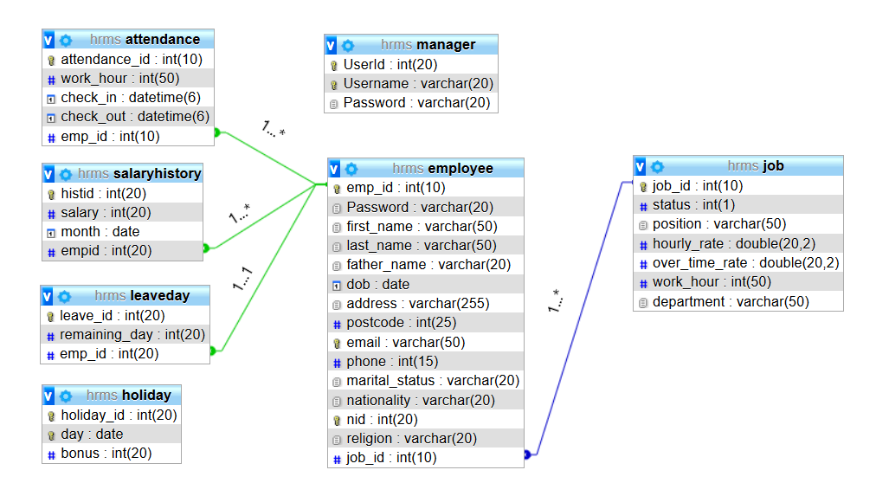

**Tools Used:**

To develop the project we used the following tools:

* Microsoft Office
* Atom
* Xampp
* Canva
* Adobe Illustrator CC 2020

**System Images against the Specification:**

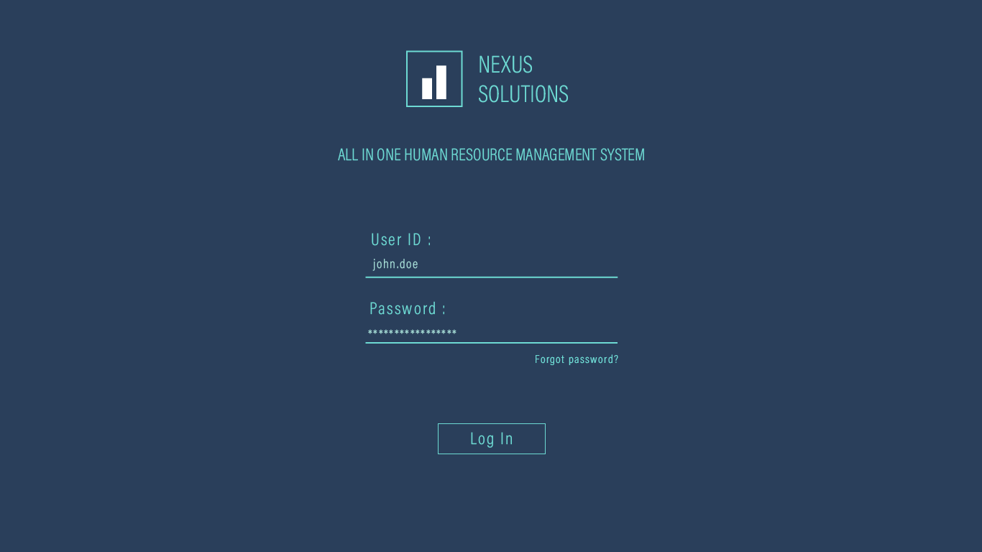

Login page for all users. There are two users which are ‘Employee’ and ‘HR Manager’. Each category of user will redirect to different homepage by logging in by given User ID and Password.

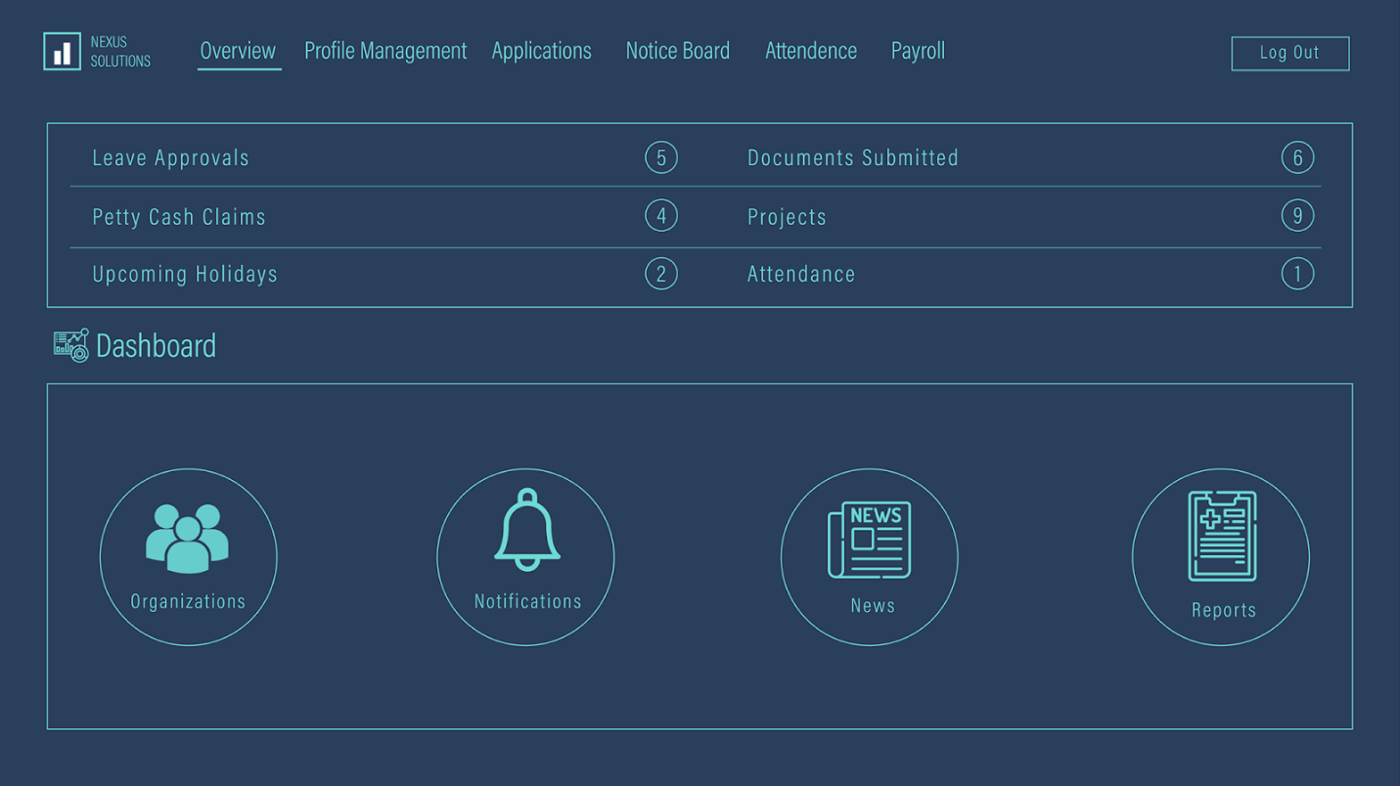

The following webpage is the homepage for the ‘Employee’ user. In the homepage, several buttons are listed which redirect the employee to specific pages. ‘Profile Management’ button will redirect to a webpage where employee’s personal information is shown. ‘Applications’ button will redirect to a webpage where the employee can request advance leave or separation. ‘Notice Board’ button will redirect to a webpage where notices or files posted by the HR manager are shown. ‘Attendance’ button will redirect to a webpage where employee’s checked in and check out attendance is shown month wise and ‘Payroll’ will redirect to a webpage which shows monthly salary history.

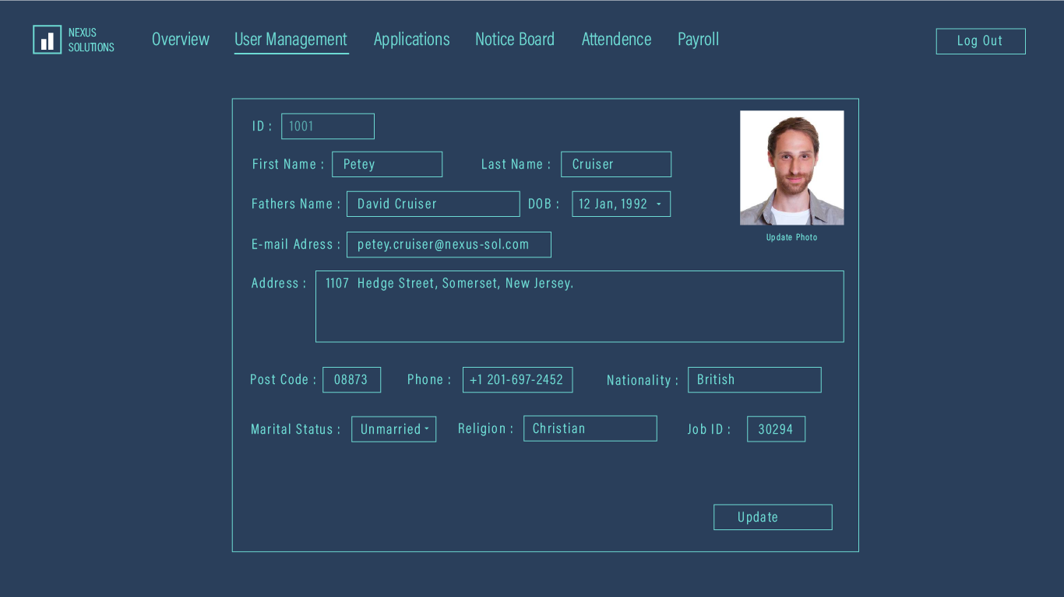

The following webpage is the profile section for the ‘Employee’ user where all the personal information is shown. By clicking the ‘Update’ button, the user can request to change his personal information which needs approval of ‘HR Manager’ to change.

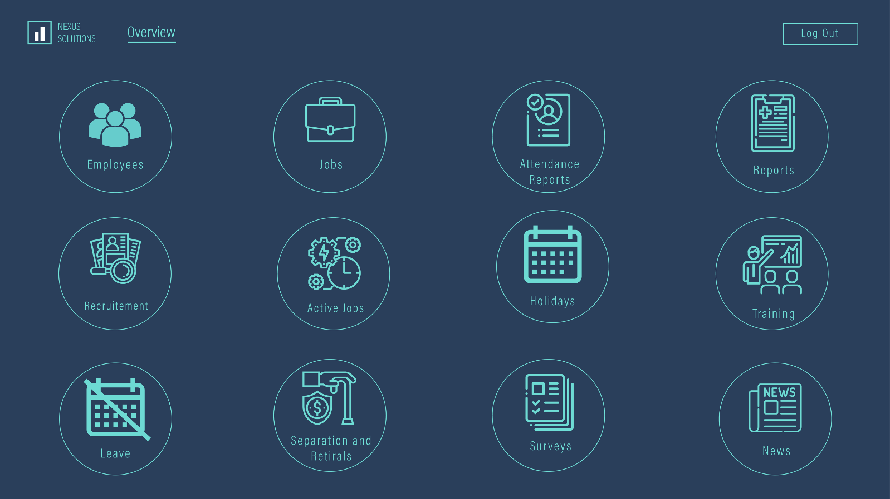

The following webpage is the homepage for the ‘HR Manager’ user. In the homepage, several buttons are listed which redirect the employee to specific pages.

‘Employee’ button will redirect to a webpage where the manager can create, search, update or delete employee’s data.

‘Jobs’ button will redirect to a webpage where the manager can create, search, update, delete jobs.

‘Attendance Reports’ button will redirect to a webpage where the manager can view attendance list based on daily, monthly of an individual employee.

‘Leave’ button will redirect to a webpage where the manager can review and approve pending leave requests.

‘Holidays’ button will redirect to a webpage where the manager can offer holidays and bonus to the specified holiday.

‘Payroll’ button will redirect to a webpage where the manager can generate and view the periodic salary list of employees, calculate various deductions and employee taxes reports.

‘Separation and Retirals’ button will redirect to a webpage where the manager can review pending permanent or temporary separation requests, schedule an interview and manage pensions.

‘Recruitment’ button will redirect to a webpage where the manager can review pending CVs and also short-listing, decision making and scheduling assistant.

‘News’ button will redirect to a webpage where the manager can post updated notices.

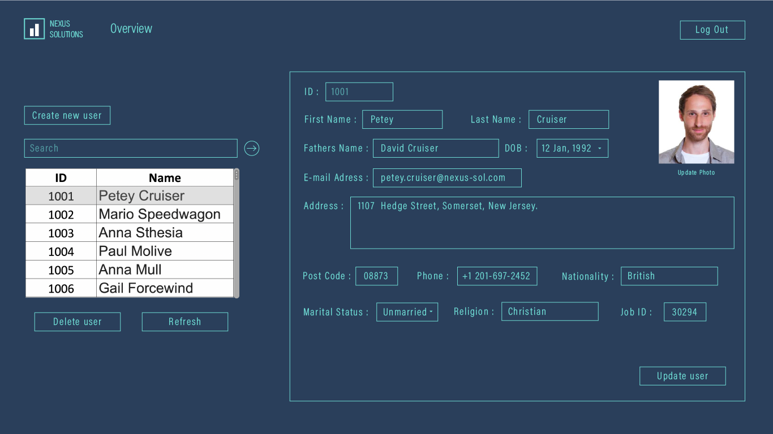

The following webpage is the ‘Employees Management’ section for the ‘HR Manager’ user where the HR manager can create new employees, search and view any employee’s personal information, update or delete individual employees.

**Impact of this Project:**

The primary goal of this project is to reduce the effort of the administrator/upper team management to keep track of the daily events such as attendance, salaries, projects, works, appointments, offered jobs, holiday/leave etc. It deals with the process of identifying the employees, recording their attendance hourly and calculating their effective payable hours or days. This system will keep up the records of every single worker and their time spent in the organization, which can be utilized for performance rating. Based on that transfer, removal, promotion can be done. There will also be a notice board where important updates or information will show up. This system will be helpful for boosting up the performances of a company, as all the manual processes will get automated. Tasks as in paper works, data manipulations and so on, those have been done manually previously all will be completely shifted to the computerized process and this HRM system will enable the company to carry out its operations more swiftly. Cost factor and wastage of time will be decreased.

**Limitations and Possible Future Improvements:**

There is no access control system to pick up attendance data on a real-time basis on the following implemented HRMS project. Once an employee logged in to the website server, attendance will be taken automatically. No fingerprint or swipe card system is configured to the system. This is a major limitation of the project which will be added during any future improvements. Additionally, the payment methods for employees are manually done by cash. Furthermore, there are no online payment services available for the employees to request salary advances or loans.

The future improvements of the application may include project management and performance management features for scheduling resources and tracking performance of each individual employee.

**_______________________________________________________________________________________________**

|  |  |  |  |  |  |
| --- | --- | --- | --- | --- | --- |
| **CO1 and CO3 Evaluation: Project Report Evaluation** | | | | | |
| **Project Proposal**  **(5)** | **Background**  **Study**  **(5)** | **Requirement Analysis**  **(5)** | **Entity**  **Diagram**  **(5)** | **System Images**  **against the**  **Specification (5)** | **Total (25)** |
|  |  |  |  |  |  |
|  | | | | | |